AAKASH JAISWAL

RA1911003010289

**E1**

**DDL AND DML Command Execution**

1. DDL COMMANDS(alter, create, modify)

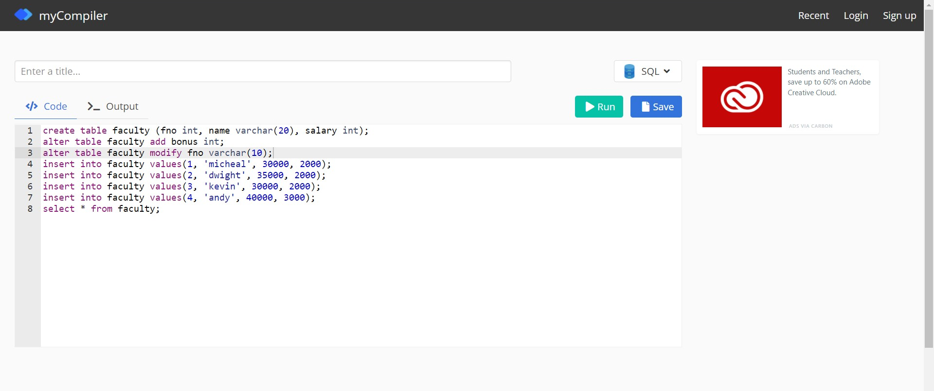

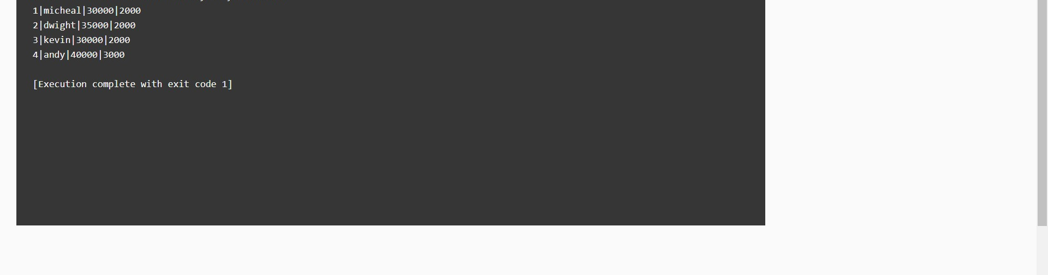

(Rename column, drop column)

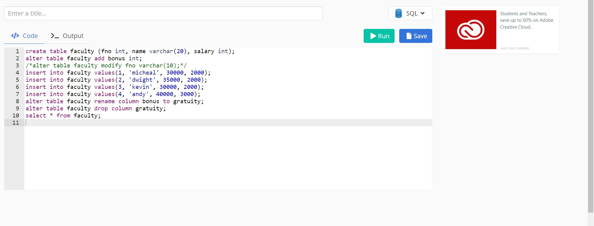

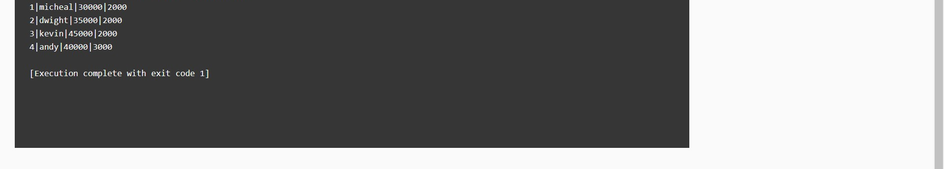

(Rename Table, Drop Table)

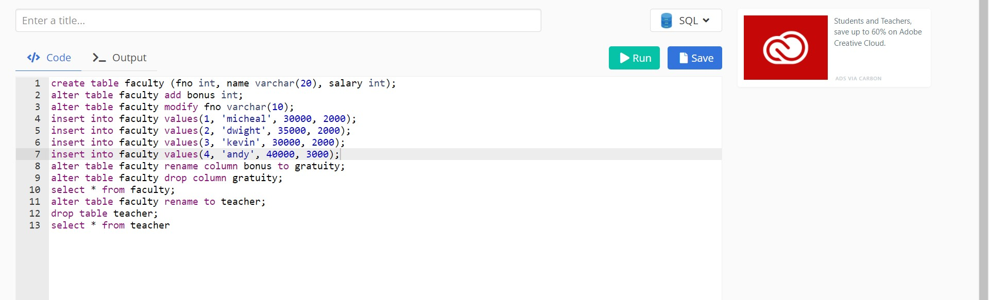



2. DML COMMANDS(Insert, Update commands)

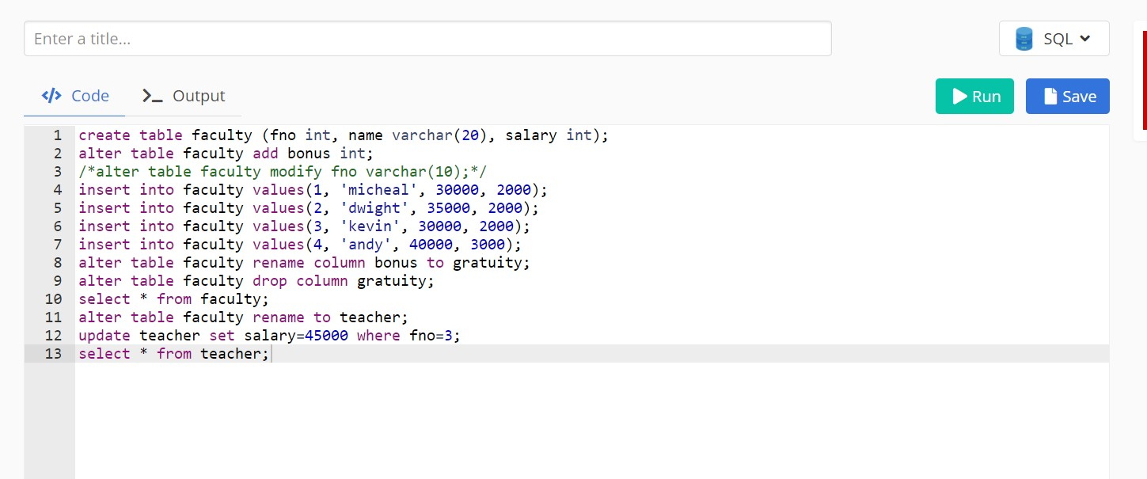

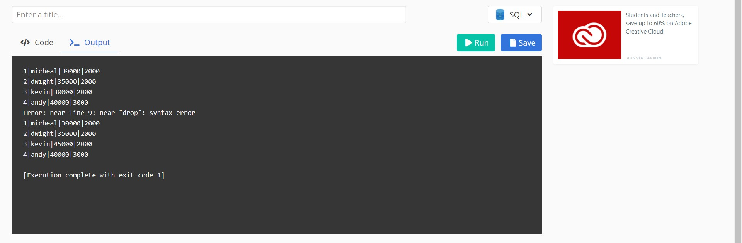

(Select Distinct)

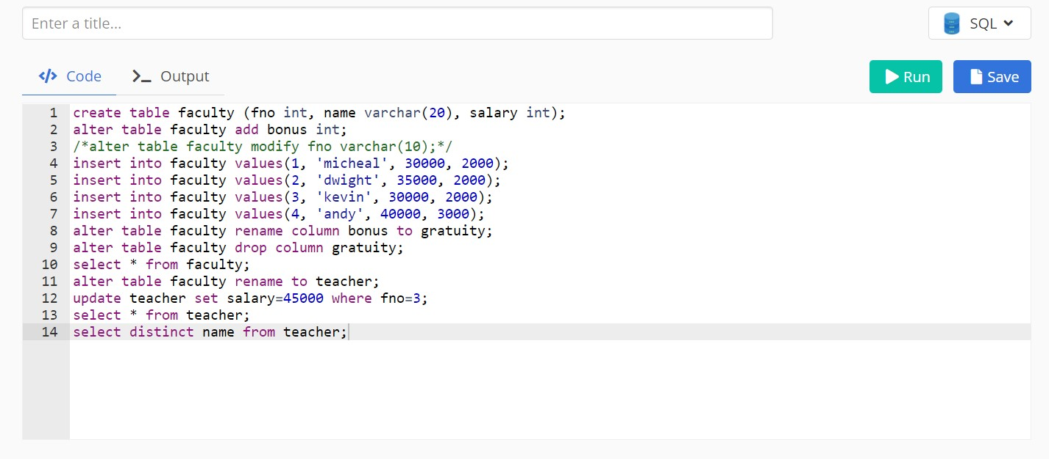

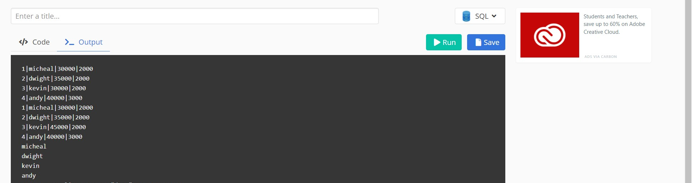

(Delete Command)

